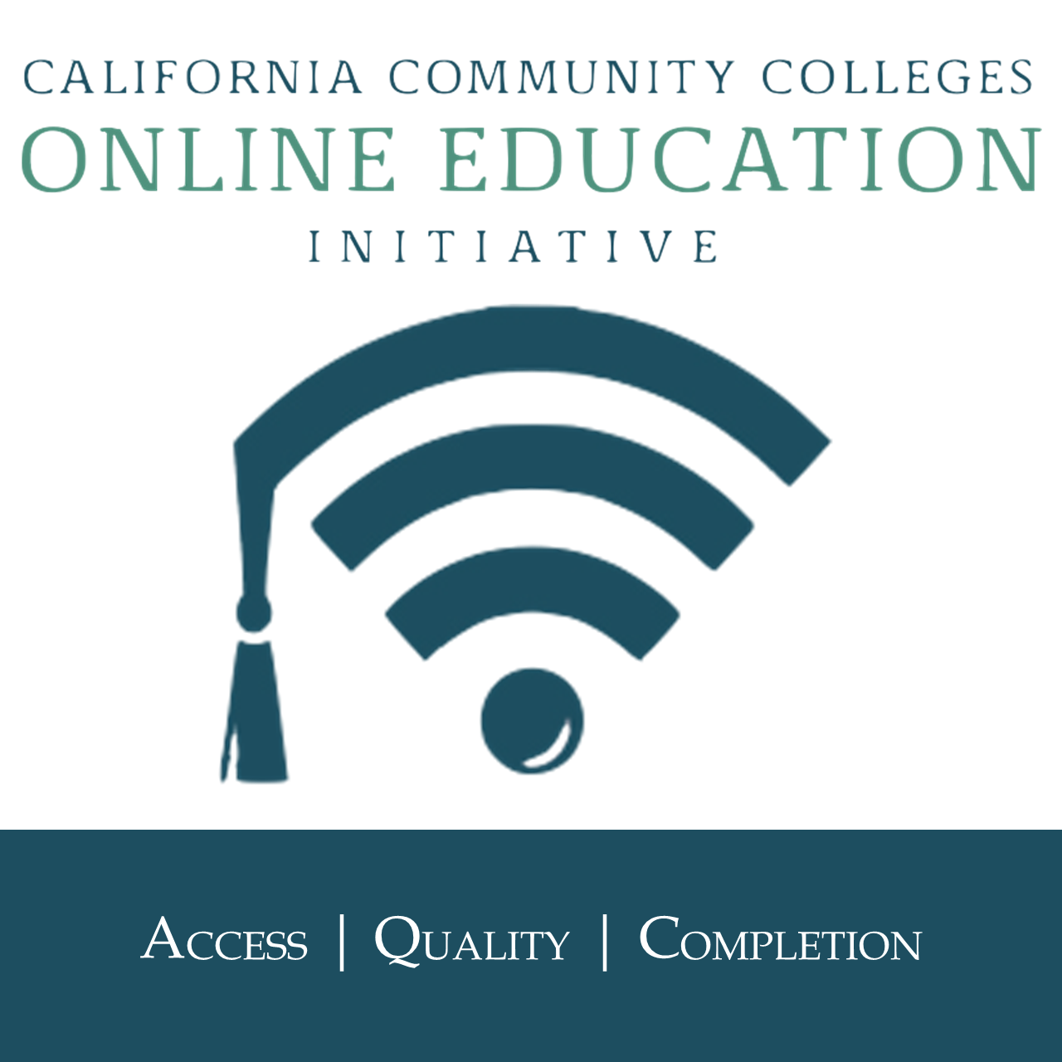

ONLINE EDUCATION INITIATIVE - CONSORTIUM MEETING MINUTES
Friday, April 20, 2018, 9:30 AM – 11:30 AM
Virtual Meeting

LIST OF ATTENDEES
Judy Baker, Dan Barnett, Wendy Bass, Lindsey Bertomen, Gregory Bormann, Will Breitbach, Naomi Caietti, Amy Carbonaro, Melissa Colon, Anita Crawley, Jay Field, Jory Hadsell, Andrea Hanstein, Marilyn Harvey, Patricia James, Kate Jordahl, Jim Julius, Steve Klein, Erin Larson, Jaye Luke, Carrie Monlux, Joe Moreau, Brett Myhren, Bob Nash, Trena O’Connor, Micah Orloff, Bonnie Peters, Michelle Pilati, John Sills, Jodie Steeley, Treva Thomas, Xochitl Tirado, Suzanne Wakim, Brian Weston

- APPROVAL OF AGENDA
The Meeting agenda was approved by consensus; no revisions.

- APPROVAL OF MINUTES
The Minutes from the March 16, 2018 meeting were approved by consensus; none opposed and no revisions.

- ONLINE EDUCATION INITIATIVE UPDATE (Jory Hadsell)
Funding for Online Services and Tools
Future plans with VeriCite/Turnitin were shared in the OEI Advisory Committee meeting two weeks ago. Conversations have taken place with Turnitin, and their plans are to keep VeriCite live and in production until next June at least. OEI is working with the Foundation on the renewal of that agreement for the coming year. OEI will pay for it for 2018-2019 as a bridge while looking at other options. Turnitin is not going to maintain VeriCite as a product beyond June; they are developing another product called WebCheck that they plan to replace it with. OEI will help colleges look at other options, but plagiarism detection costs will be shifted to colleges. An invoice was sent to some colleges by Turnitin this past week which was sent in error and can be disregarded. Messaging will come from OEI to provide additional clarity.

Going forward in Year 5 of the grant and expansion of the Consortium, OEI will be looking at potential models for sharing the costs of some of the online services. As more colleges join, there is a limited pool of funds to work with for sustainability, and models will be phased in after this coming year. Services and tools will be maintained for this coming year 2018-2019.

Joe added that Canvas is full funded and covered 100% ongoing.

Micah asked a question about what are the Consortium college’s requirements moving forward? Jory replied that there will be more clarity in July about what the requirements/expectations will look like, but the core components of the ecosystem are Tutoring, Counseling, and Readiness. Depending on what the OEI can negotiate with the vendors, the OEI will may fully fund some costs and then share with the colleges. The OEI will keep colleges updated on the 2019-2020 budget. Micah commented that he has been contacting vendors for quotes and budget projections, but the vendors are referring the college back to the OEI. He wants to know what the costs could be and determine local projections. Micah would like the OEI to clear vendors to give colleges a quote in Consortium and outside of the Consortium. Jory agreed and referred colleges to Jorge Burwich at the Foundation/College Buys: jburwick@foundationccc.org. Contact Jory or Marilyn if follow up is needed.

Summer 2018
Colleges should have received a letter regarding the pause on development and deployment of the Course Exchange cross-registration as the OEI shifts to a different model. There are plans to promote summer courses for extra exposure to aligned courses. There will be more information at the May Consortium meeting. Advice for summer is to continue reviewing courses and to motivate faculty. The OEI will support colleges in the summer. The OEI understands that the shift in the cross-registration piece can be disruptive, but ultimately based on feedback from colleges and the student experience as well as the vision of the Chancellor’s Office for Phase 2 of the project, there needed to be a pivot before Fall. Excited for new opportunities.

There was a question on timelines and the best case scenario with the next steps for the Course Exchange. Jory replied that the cross-registration is the most complex piece due to the different systems with Peoplesoft, Banner, and Colleague. There have been several years for this trajectory, and the Chancellor’s Office requested in February to review build vs. buy models in the marketplace after four years. There are positive options to do the cross-registration piece in a more scalable, sustainable, and faster way to benefit the colleges. Look at the vision beyond the current semester and help students with a broader mechanism. In summer, there will be marketing efforts to help expose students to your courses from all three systems through an open and searchable way.

Andrea also replied that the OEI has hired a marketing firm, 25th Hour to get a jumpstart on fall registration. They have conducted interviews with all the SPOCs currently live in the Course Exchange, their marketing directors, and students about their experiences in the Course Exchange. They will use these preliminary findings to market summer and fall 2018. At the May Consortium meeting, colleges will receive print and electronic marketing materials, and the OEI is doing some paid marketing as well.

Carrie asked a question about what was the OEI Advisory Committee’s comments regarding the pause? Jory replied that they had some questions in terms of process and what is coming for summer and fall. Because of the RFA process and renewal of the grant, conversations limited to 2017-2018 to ensure equity for anyone wanting to apply going forward. The Advisory Committee understands the challenges that the OEI had and with accountability to the Chancellor’s Office. The Chancellor’s Office has been very clear about the need to scale and their expectations around timeline with the vision that they laid out. Based on where things were to date with the product and cross-registration, there was a need to go in a different direction.

Wendy added that at there were a lot of questions in the Advisory Committee meeting, and a lot of them want to get their schools in the Consortium rather than some of the behind the scenes information. There were questions about the RFA, but understanding that it is a confidential process. Impressed with how many courses (110) are OEI Rubric Aligned and ready to go for cross-registration. There was concern with the 20 seats reserved in the Course Exchange. Everyone is excited to see it move forward.

Consortium Expansion Update (Kate Jordahl)
The 2018 Consortium Cohort will focus on student equity. 49 colleges submitted a letter of interest, and 33 colleges submitted self-assessment packets. The names of the colleges will be announced on Wednesday, April 25 at 9am on the OEI website. There will also be a hashtag #welcomewednesday around the different colleges that will be joining. New colleges will start preparing now with the Course Design Academy and creating OEI local teams. They will sign the Consortium Agreement and officially join in July, 2018. Implementation contacts for any questions are Kate Jordahl, Director of Operations (kjordahl@ccconlineed.org), Justin Schultz, College Implementation Supervisor (jschultz@ccconlineed.org), and Karen Oeh, College Support Representative (koeh@ccconlineed.org).

Michelle asked how many colleges will be joining? Kate replied that the announcement will be made on Wednesday.

- DISASTER/DISRUPTION PLANNING WORKSHOP (Pat James)
The OEI is working to create a guideline for disaster planning using our digital tools, including CANVAS. There are many examples of disasters and disruptions at California Community Colleges: Butte (Oroville Dam potential flood), Santa Rosa and Ventura (fires), MSJC (wind storm/sand), Columbia (snow storm). Additionally, faculty may not be able to finish a class due to illness, death, termination, etc.

Pat is working on a webinar and interviewing college personnel about what it was like to deal with the situation and how they handled it. A college may not be able to keep instruction going on campus, but there may be possibilities to use the CANVAS system with students to keep online instruction going. Pat would like Consortium members who have undergone a situation with a disaster or disruption, to share their information and email her: pjames@ccconlineed.org. She would like to interview you, collect effective processes, and see how you resolved the situation. A question was posed, “What do we need to do as a college proactively?”

A guideline for disaster planning is a way the OEI can help, in collaboration with some of our technology partners, and it may be a model for other systems and institutions. We can be proactive with policy and technology. Additionally, a webinar can be part of professional development for faculty and administrators.

- INFORMATIONAL – OEI EVALUATION UPDATE (Alyssa Nguyen, RP Group)
Alyssa shared updates on the past year’s evaluations activities and some general information on what is being planned. She shared highlights from the student and faculty survey results, specifically around the satisfaction and usage of the OEI products and services. She also shared highlights from the statewide OEI survey results from questions that were embedded in the Chancellor’s Office Distance Education Coordinators survey as well as the statewide faculty survey that was sent out from the Chancellor’s Office. She provided some information around the course success outcomes comparisons from OEI pilot sections compared to success rates from the OEI pilot colleges and statewide numbers. Followed by the activities completed in Fall 2017 and then our plans for Spring 2018.

OEI Pilot Section Experiences
Students’ Experiences with Canvas Compared to Other CMSs, Results Across Surveys
- Fall 2015: 55.8% (Better), 37.2% (The Same), 7.0% (Worse)
- Spring 2016: 42.0% (Better), 42% (The Same), 16% (Worse)
- Fall 2016: 63.8% (Better), 29.3% (The Same), 7.0% (Worse)
- Spring 2017: 70.5% (Better), 23.0% (The Same), 6.6% (Worse)
- N = 40 – 100 per term
- Spring 2017 N = 100

OEI Pilot Section Experiences
OEI Support Services Usage among 84 students
- Quest: 75.0% (Did not know about it/heard about it), 13.1% (Participation)
- Net Tutor: 41.5% (Did not know about it/heard about it), 7.1% (Participation)
- Proctorio: 77.4% (Did not know about it/heard about it), 2.4% (Participation)
- VeriCite: 63.1% (Did not know about it/heard about it), 10.0% (Participation)
- Note: information from spring 2017 end of term survey

Statewide OEI Awareness and Usage
100% of all DE Coordinators were aware and had some level of engagement with OEI
Reported Usefulness of OEI Products by Distance Education Coordinators
- Canvas (N=113): 90.3% (Useful), 4.4% (Somewhat useful), 0.9% (Somewhat not useful), 0.0% (not at all useful), 4.4% (Not Applicable/Have not used)
- NetTutor (N=112): 51.8% (Useful), 15.2% (Somewhat useful), 2.7% (Somewhat not useful), 1.8% (not at all useful), 28.6% (Not Applicable/Have not used)
- Quest for Online Success (N=112): 49.1% (Useful), 13.4% (Somewhat useful), 3.6% (Somewhat not useful), 0.9% (not at all useful), 33.0% (Not Applicable/Have not used)
- VeriCite (N=112): 30.4% (Useful), 8.0% (Somewhat useful), 0.9% (Somewhat not useful), 0.9% (not at all useful), 59.8% (Not Applicable/Have not used)
- ConexEd (N=111): 38.7% (Useful), 10.8% (Somewhat useful), 2.7% (Somewhat not useful), 1.8% (not at all useful), 45.9% (Not Applicable/Have not used)
- OEI Course Design Rubric (N=112): 74.1% (Useful), 14.3% (Somewhat useful), 1.8% (Somewhat not useful), 0.0% (not at all useful), 9.8% (Not Applicable/Have not used)
- OEI Exchange (N=112): 26.8% (Useful), 6.0% (Somewhat useful), 3.6% (Somewhat not useful), 2.7% (not at all useful), 60.7% (Not Applicable/Have not used)

OEI Outcomes on Course Success
Online Course Success Rate Comparisons: OEI Pilot Sections vs. Statewide
Fall 2016 and Spring 2017 Success Rates
- OEI Pilot Sections: 67.4%
- OEI Pilot Colleges Overall: 64.4%
- Statewide Overall: 62.5%
- 4.9% higher than statewide figures
- Data Source: CCCCO’s Data Mart for all credit, internet-based courses matched on the same TOP code. OEI pilot data based on data voluntarily submitted by pilot colleges and does not include ALL OEI pilot sections.

Statewide OEI Awareness and Usage
43.5% of all faculty were aware and had some level of engagement with OEI
12.8% had never heard of OEI
- Canvas (N= 36): 59.5% (Aware, Used), 16.4% (Aware, Plan to use), 13.4% (Aware, Not Used), 4.8% (Aware, No Plans to Use), 6.0% (Never Heard Of)
- NetTutor (N=331): 15.7% (Aware, Used), 6.9% (Aware, Plan to use), 33.5% (Aware, Not Used), 6.0% (Aware, No Plans to Use), 37.8% (Never Heard Of)
- Quest for Online Success (N=333): 11.1% (Aware, Used), 5.1% (Aware, Plan to use), 22.2% (Aware, Not Used), 2.7% (Aware, No Plans to Use), 58.9% (Never Heard Of)
- VeriCite (N=330): 4.2% (Aware, Used), 4.5% (Aware, Plan to use), 30.9% (Aware, Not Used), 5.8% (Aware, No Plans to Use), 54.5% (Never Heard Of)
- ConexEd (N=329): 2.7% (Aware, Used), 3.0% (Aware, Plan to use), 19.8% (Aware, Not Used), 1.8% (Aware, No Plans to Use), 72.6% (Never Heard Of)
- OEI Course Design Rubric (N=331): 24.5% (Aware, Used), 12.1% (Aware, Plan to use), 25.1% (Aware, Not Used), 5.1% (Aware, No Plans to Use), 33.2% (Never Heard Of)
- OEI Exchange (N=328): 3.7% (Aware, Used), 7.0% (Aware, Plan to use), 25.9% (Aware, Not Used), 6.4% (Aware, No Plans to Use), 57.0% (Never Heard Of)

Fall 2017 Evaluation Updates
Overall Online Learning and Teaching Experience
- Focus on overall online learning and teaching experiences
- Awareness, usage, and satisfaction with OEI products and services
Student Findings (N=141)
- 90% enrolled in online course because it fit their schedule
- 98% were satisfied with opportunities to communicate with faculty
- 96% agreed that the course effectively used technology tools
Student Findings (N-141): Used Service
- Quest for Success (N=135): 51.1% (Yes), 48.9% (No)
- NetTutor (N=134): 26.9% (Yes), 73.1% (No)
- Proctorio (N=134): 6.0% (Yes), 94.0% (No)
- VeriCite (N=134): 33.6% (Yes), 66.4% (No)
- ConexEd (N=132): 1.5% (Yes), 98.5% (No)
Of the student who did not use an OEI product/service:
- Quest for Success (N=135): 70.4% (Did not know about it or what it was), 39.1% (Did not need it), 7.9% (Used another comparable service)
- NetTutor (N=134): 36.6% (Did not know about it or what it was), 62.4% (Did not need it), 17.2% (Used another comparable service)
- Proctorio (N=134): 82.6% (Did not know about it or what it was), 22.3% (Did not need it), 8.3% (Used another comparable service)
- VeriCite (N=134): 90.6% (Did not know about it or what it was), 31.8% (Did not need it), 2.4% (Used another comparable service)
- ConexEd (N=132): 92.0% (Did not know about it or what it was), 23.2% (Did not need it), 0.8% (Used another comparable service)
- Note: percentages do not equal 100% because students were allowed to check multiple options.
Faculty Findings (N=68)
- 100% felt students were engaged in their online learning
- 94.1% felt Canvas positively affected their online teaching experience
- Approximately 20% of faculty did not know about Quest, Proctorio, or VeriCite
- 65% made NeTutor available to students (highest), 19% made Proctorio available (lowest)

Spring 2018 Plans
Evaluation Activities
- Interviews with Exchange deployment team leads at the colleges
- Collect fall 2017 student level records to examine course outcomes
- Complete 2016-2017 dissemination brief
- Write up a summative evaluation report

Micah asked a question if she is going to interview those that went live only or those that were at different phases of implementation? Alyssa replied that they are targeting those that have gone live with at least one course, and there will be some discussions around whether or not they want to take a look at those at different phases.

Jim brought up a point that it would be helpful to know about how the success rates compare to the OEI instructors prior to their courses becoming exchange-ready. Alyssa agreed.

Bob asked if the survey use the term ConEx Ed or Cranium Café with the students? Alyssa will need to go back and double-check because she believes Cranium Café was used in the survey. Bob mentioned that at his college the term video counseling or video student services is used so students would not even know it by Cranium Café. The question needs more explanation on what ConEx Ed means, even Cranium Café. Jodie added that her college had 113,000 minutes used in NetTutor last year. Alyssa agreed that more colleges are actively using NetTutor more than others. Another college that has used it frequently is Foothill College. Jory commented that this is the 2016-2017 data. With real-time reporting, there has been a real uptick in the usage of NetTutor. Alyssa reminded members that what was being displayed on the slide was not a change, it was just percentage points.

- PROFESSIONAL DEVELOPMENT UPDATE (Autumn Bell/Kate Jordahl)
Can-Innovate 2018 educational technology conference will be untethered, and the date is October 26, 2018. Last year the event was hosted by American River College and travel was required. Digital Learning Day was untethered and also very successful, trying Can-Innovate as an untethered conference this year. Benefits will be to save travel costs and take advantage of an event on the local campuses for professional development.

The Professional Development team offered three workshops on Building a Local POCR Process. Ninety-nine people signed up for the workshops.

- ACADEMIC AFFAIRS UPDATE (Marilyn Harvey)
Marilyn sent emails to some Consortium members regarding checking courses she and Logan updated on the pathways. Please let her know if any corrections are needed. They are continuing to add to the matrix list with colleges that are not live to get a sense of what courses in the CSU pathway have been offered online. Fairly soon will provide a list with the schools that are coming onboard. Please provide feedback so they do not miss anything.

Marilyn asked if someone who attended the Academic Senate Plenary could share the outcome of the lab resolutions. Michelle offered that the Spring 2018 resolutions are available as a PDF under ASCCC.org and search Plenary. There is a resolution #9.03 called “Effective Practices in Online Communication Courses” that addresses the communication course.

Regarding vendor updates, they are starting to work with the Foundation on contracts. Reiterated that quotes will be directed to the Foundation.

The Academic Affairs team is working on a number of projects, much of them tied to moving forward. Excited to share in May. Marilyn is considering doing a survey to the Distance Education Coordinators so you may hear from Logan and Marilyn in the near future to seek information.

- STUDENT SERVICES UPDATE (Bonnie Peters)
Bonnie directed Consortium members to the Foundation/College Buys for questions on pricing for vendors with Student Services. The Foundation negotiates for colleges and a system-wide contract.

Jessica the Student Support Services and Outreach Supervisor is leaving in 3 weeks. She is going to be working with San Diego City College as the Director of Upward Bound. Bonnie and Marilyn will ensure there is no disruption in the counseling platform/online classes.

In collaboration with @ONE and as part of the Online Teaching Certificate developed the Cultural Responsive Teaching Equity course for instructors. It is a four-week course and right now they are in week three. It’s the beginning of a series of equity focused practices that will be beyond instruction. Trying to focus on the institution as a whole so this is the first in that series of courses. Feedback from instructors taking the course has been really positive.

Reminder for colleges who have not been using Quest. We just did a review and we are finding that new colleges coming on board and then some colleges in the semester not using it. We will look into the reason why colleges were using it one semester and not the other and then back using it again. Remind your instructors to use it; it is free for students to participate.

Wendy commented that she set it as a universal announcement to all students rather than sending it to faculty and asking them to send it to students. When students log into Canvas, the announcement has a direct link for students to self-enroll.
Bonnie stated that we do know that getting it to students in the very beginning is still a challenge and working on it with Intellify to get details and inform us of what we will do next. Ventura and Cabrillo using the mechanism that Intellify has created for us to get that data, do an end of the semester review, and determine what comes next.

Micah added that they auto-enroll everyone. Wendy followed up with a question about auto-enrolling students. At her college, there were 40 short term courses and there was no way for her to send a message to just those courses. She likes the auto-enroll option and will follow up with her District on doing that.

- SELECT MEETING DATE FOR JUNE 2018 (Wendy Bass)
June Virtual Consortium Meeting will be on Friday, June 15, 2018, 9:30 AM – 11:30 AM

- OEI HIGHLIGHTS – SHARE WHAT IS WORKING AT YOUR SCHOOL
Jodie asked a question about how we are going to strategically meet the requirements that are in the new RFA? Jory replied that we are taking the conversation out of this venue in fairness to those wanting to apply. We did talk a little bit about summer and diving deep into that at our May F2F meeting, including having marketing materials available as well as more openly share what we are working on for summer. We are focused on those targets, the pivot on the cross-enrollment technology is a component of that.

Jodie discussed the benefits of how the students are benefiting from the OEI/CVC, and the RFA is very specific in what the Consortium colleges will be asked to do no matter who holds the grant in the fall. Think about the students and the Consortium colleges who are trying to uphold their end of the bargain with holding 20 seats per course, offering a specific number of courses ready for the Course Exchange once the technology is reopened to allow that. With the RFA out there, she emphasized being student centered and meeting the needs of the RFA as Consortium colleges. There are a lot of components of the OEI we can talk about and those are positive for the students.

Jory replied that one of the pieces we can talk about now is continuing on with course reviews. The OEI Professional Development team is working with current colleges as well as those that applied to be part of the expansion in building localized review teams to pump up the number of courses aligned to the rubric. Another way of looking at being student focused is how we integrate support technologies. The piece around the number of seats, those components, are part of a construct that we’ve had within the limitations of our current technology. The OEI is definitely focused on working with each college in the Consortium to bring as many rubric aligned courses forward for summer and fall. This will happen by building out the local process and through leveraging the existing process. We are looking at how we meet degree and ADT requirements as well.

- Wendy: many faculty using Proctorio, making a huge difference and allowing courses to go online with the ability to Proctor them. Turned around the philosophy on her campus knowing that students cannot cheat online.
- Carrie: faster DE course approval process.
- Jim: working with Bonnie, Arnita, and Marilyn and getting a huge interest in using Cranium Café for all kinds of student support services.
- Micah: Retention rate for online virtual counseling appointments is very high, only 2 weeks out.

- UPCOMING MEETING SCHEDULE
- Friday, May 11, 2018 – F2F Meeting (Sacramento) – 10:00AM-3:30PM
- Friday, June 15, 2018 – Online Meeting – 9:30AM-11:30AM

